Name: Weekly Language Review – Q4:2 Week of:
Monday | Tuesday
  Write the missing letters. Write the word.  ider  mmm.. | Draw a picture to show the opposite of BACK.  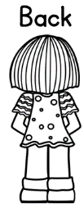
Spell the word.  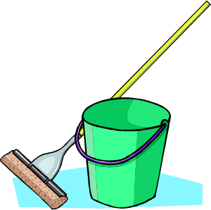  Mm | Circle the missing word.  Who What When  ___ color crayon do you want?
Circle the NOUN. Underline the VERB.  The cat played. | Add detail to the sentence.  The cat played.  The ////// cat played.
Act it out.  - hit  - push  - tap | Draw a picture of something tall.
Which picture matches the underlined word?    Her ring is shiny. | Which picture matches the underlined word?  Ring the bell when you are done.

Wednesday | Thursday
Circle the missing word.  out on off  She walked ____ the door. | How many syllables in backpack?  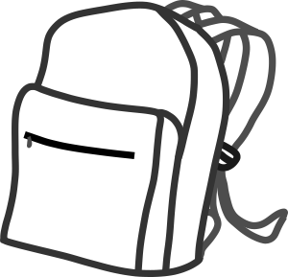 //
Spell the word.  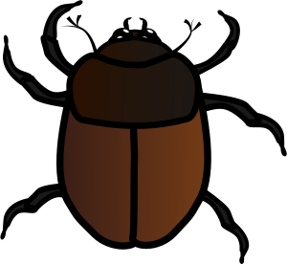  /m | Write the sentence correctly.  ella and i rode a horse  mmm..
Circle the NOUN. Underline the VERB.  Jamie cooked cookies. | Add detail to the sentence.  Jamie cooked cookies.  Jamie cooked ////// cookies.
Act it out.  - sit  - lay  - squat | Draw a picture of something yummy.
Which picture matches the underlined word?  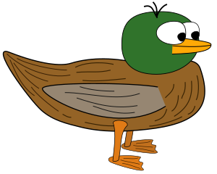  The duck swam in the lake. | Which picture matches the underlined word?  Be sure to duck under the branch.

Answer Key - Weekly Language Review – Q4:2
Monday | Tuesday
Write the missing letters. Write the word.  spider  mmm.. | Draw a picture to show the opposite of BACK. Front
Spell the word.  mop | Circle the missing word.  Who What When  ___ color crayon do you want?
Circle the NOUN. Underline the VERB.  The cat played. | Add detail to the sentence.  The cat played.  Answers will vary.  The ////// cat played.
Act it out.  - hit  - push  - tap | Draw a picture of something tall.
Which picture matches the underlined word?  Her ring is shiny. | Which picture matches the underlined word?  Ring the bell when you are done.

Wednesday | Thursday
Circle the missing word.  out on off  She walked ____ the door. | How many syllables in backpack?  2
Spell the word.  bug | Write the sentence correctly.  ella and i rode a horse  Ella and I rode a horse.
Circle the NOUN. Underline the VERB.  Jamie cooked cookies. | Add detail to the sentence.  Jamie cooked cookies.  Answers will vary.  Jamie cooked ////// cookies.
Act it out.  - sit  - lay  - squat | Draw a picture of something yummy.
Which picture matches the underlined word?  The duck swam in the lake. | Which picture matches the underlined word?  Be sure to duck under the branch.

